Supplier`s declaration of conformity (DoC)

We ( manufacturer or authorized representative):

Business name: Cool Creation
Address: Joseph van Instraat 5 bus 1b, 2500 Lier
Country: Belgium

Declare under our responsibility for the equipment:

Equipment name: Potholder printed
Model type: 22NB012-02
Batch or serial number: CCPO21-0002
Object ( color picture )
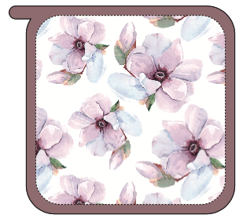
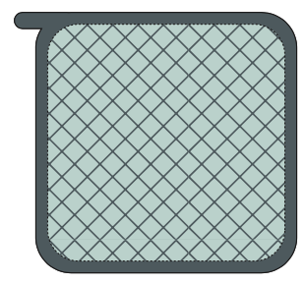
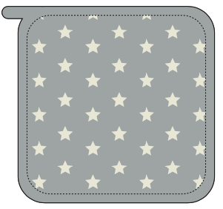

That the equipment is in conformity with the following relevant Union harmonization legislation:
- Regulation 425/2016/EU
- Oeko-tex 100
- reach

And that the equipment is in conformity with the following harmonized standards and/or other normative documents or technical specifications:
- EN 407:2004
- EN 420:2003+A1.2009
- BS 6526:1998
- EN 407:2020

Place and date of issue (of this DoC): 02-12-2021 Lier

Signed by or for the manufacturer:

